**What you need to know about calculations**

Mathematics will be at the core of your child’s schooling from the moment they start to the moment they leave. They will be involved in drawing, measuring, handling data and lots of other practical activities that will help your child to understand and enjoy the subject. This booklet offers guidance to the methods used to help our pupils with calculations. The methods we are advocating are in line with the new National Curriculum (from September 2014). We hope this will be helpful to you and that you will be able to support your child in learning by heart the basic rules which will assist in mental recall eg. number bonds and multiplication tables.

The methods that we use in school may or may not be familiar to you. Children are often confused when they ask parents for help at home and they try to teach the methods that *they* themselves were taught. Knowing how the methods in this booklet work will help you to help your children.

All staff in school work from this document so that we can ensure the consistency of our approach and can make sure that the children move onto the next step when they are ready.

The four operations that are covered by this booklet are addition, subtraction, multiplication and division. Whichever operation is being taught the child needs to experience all of these steps to completely conquer it.

1. Using concrete objects
2. Using visual/pictorial representations
3. Using abstract methods

Mental methods first

Children should always be encouraged to consider if a mental calculation would be appropriate before using written methods. – These are covered in the first part of each section.

Why do children need to do written calculations?

* To represent work that has been done practically.
* To support, record and explain mental calculation
* To keep track of steps in a longer task
* To work out calculations that are too difficult to do mentally

Children should be taught when it is appropriate to do an approximate or estimate first and should check with the inverse operation at the end.

By upper Key Stage 2, children should be confident in choosing and using a strategy that they know will get them to the correct answer as efficiently as possible.

What can parents do to help?

* Count with their child
* Play number games
* Involve children when taking measurements or weighing items
* Take note of numbers in real life e.g. telephone numbers, bus numbers, lottery numbers etc.
* Give children opportunities to use money to shop, check change etc.
* Talking about the mathematics in football e.g. ‘How many points does your favourite team need to catch the next team in the league?’
* When helping their children calculate use the method that they have been taught

Please don’t…

* Teach your children that to multiply by 10 you ‘just add a zero’. – you ‘move the digits to the left and add a zero as a place holder’
* Tell them that you can move the decimal point. – You can’t. You can only move the digits to the left or to the right
* Tell them that they are doing ‘sums’ – ‘sum’ is a mathematical word that means ‘addition’, everything else is a ‘calculation’

**Resources that your children will use to help with calculation**

**Dienes** **Cubes, Counters, Dice**

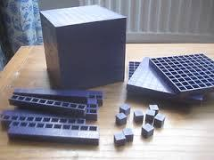

Dienes, although it has been used in schools for years is a crucial step in knowing what a ‘one’ (unit), a ten, a hundred and a thousand look like and how they can be added together and split up to form smaller and larger numbers.

**Numicon**

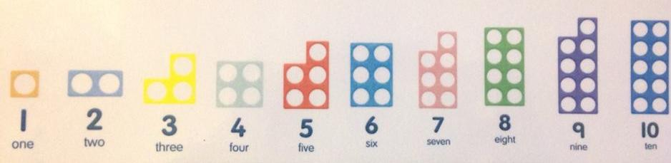

Numicon is an especially useful resource as it can be used for teaching all four operations as well as fractions, decimals, percentages and a range of other aspects of maths. Each piece represents an integer from 1 to 10.

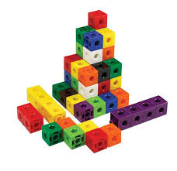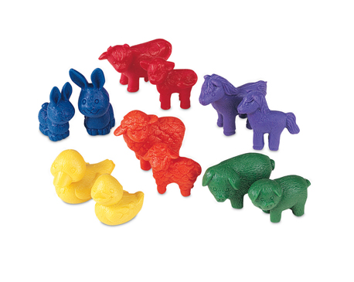



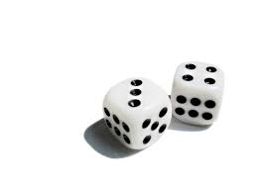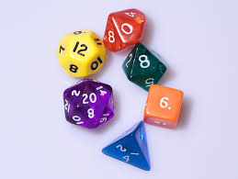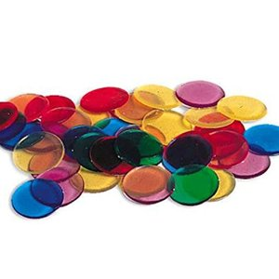

Cubes, counters and dice play a key part in developing the children’s understanding of number, place value and calculation, by providing children with opportunities to physically manipulate objects and see the comparative sizes of things.

**Numberlines**

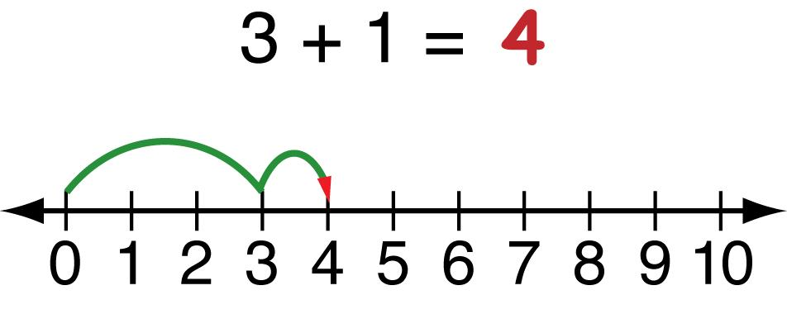

Numberlines are a mainstay of teaching calculations. We have pre numbered and blank numberlines in school that children can write on, or they can draw their own as appropriate for the calculation. In years 5 & 6 the children are encouraged to draw their own numberlines, as required to assist them with calculations.

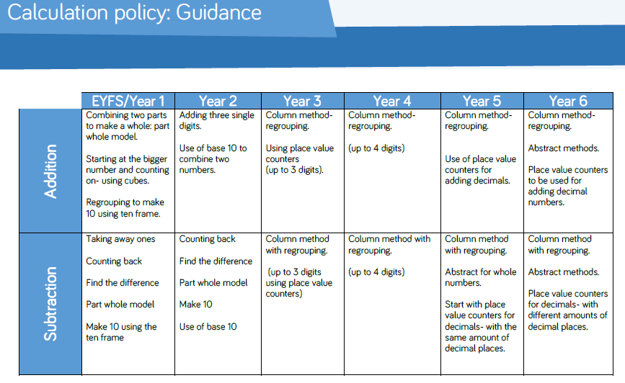

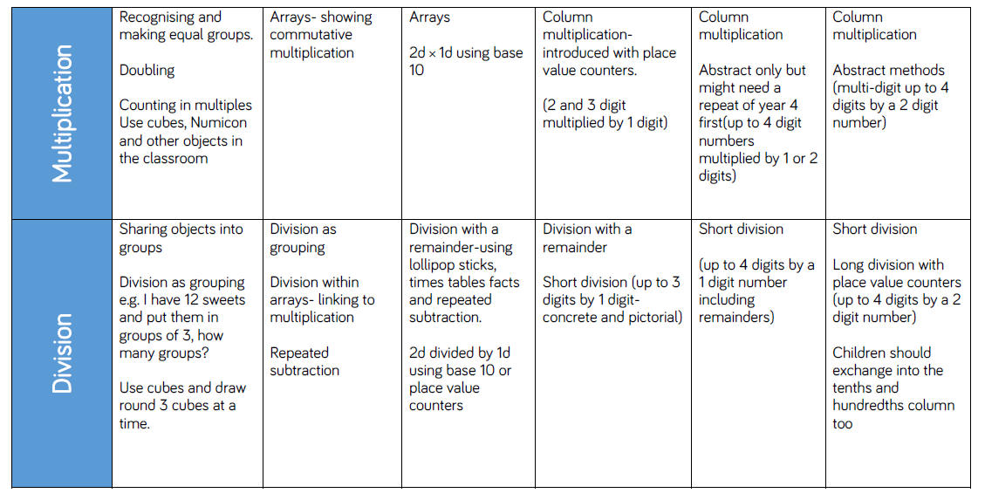

|  |  |
| --- | --- |
| **End of year expectations - Year 3** | **End of year expectations - Year 4** |
| **Addition and Subtraction**  Pupils should be taught to:   * add and subtract numbers mentally, including: a three-digit number and ones; a three-digit number and tens; a three-digit number and hundreds * add and subtract numbers with up to three digits, using formal written methods of columnar addition and subtraction * estimate the answer to a calculation and use inverse   operations to check answers.   * solve problems, including missing number problems, using number facts, place value, and more complex addition and subtraction. | **Addition and Subtraction**  Pupils should be taught to:   * add and subtract numbers with up to 4 digits using the formal written methods of columnar addition and subtraction where appropriate * estimate and use inverse operations to check answers to a calculation * solve addition and subtraction two-step problems in contexts, deciding which operations and methods to use and why. * solve addition and subtraction two-step problems in contexts, deciding which operations and methods to use and why. |
| **Multiplication and Division**  Pupils should be taught to:   * recall and use multiplication and division facts for the 3, 4 and 8 multiplication tables * write and calculate mathematical statements for multiplication and division using the multiplication tables that they know, including for two-digit numbers times one-digit numbers, using mental and progressing to formal written methods * solve problems, including missing number problems, involving multiplication and division, including integer scaling problems and correspondence problems in which n objects are connected to m objects. | **Multiplication and Division**  Pupils should be taught to:   * recall multiplication and division facts for multiplication tables up to 12 × 12 * use place value, known and derived facts to multiply and divide mentally, including: multiplying by 0 and 1; dividing by 1; multiplying together three numbers * recognise and use factor pairs and commutativity in mental calculations * multiply two-digit and three-digit numbers by a one-digit number using formal written layout * solve problems involving multiplying and adding, including using the distributive law to multiply two digit numbers by one digit, integer scaling problems and harder correspondence problems such as n objects are   connected to m objects. |

|  |  |
| --- | --- |
| **End of year expectations - Year 5** | **End of year expectations - Year 6** |
| **Addition and Subtraction**  Pupils should be taught to:   * add and subtract whole numbers with more than 4 digits, including using efficient written methods (columnar addition and subtraction) * add and subtract numbers mentally with increasingly large numbers * use rounding to check answers to calculations and   determine, in the context of a problem, levels of  accuracy   * solve addition and subtraction multi-step problems in contexts, deciding which operations and methods to   use and why.  **Multiplication and Division**  Pupils should be taught to:   * identify multiples and factors, including finding all factor pairs * solve problems involving multiplication and division where larger numbers are used by decomposing them into their factors * know and use the vocabulary of prime numbers, prime   factors and composite (non-prime) numbers   * establish whether a number up to 100 is prime and recall   prime numbers up to 19  **Year 5** **Multiplication and Division continued:**   * multiply numbers up to 4 digits by a one- or two-digit number using an efficient written method, including long multiplication for two-digit numbers * multiply and divide numbers mentally drawing upon known facts * divide numbers up to 4 digits by a one-digit number using the efficient written method of short division and interpret remainders appropriately for the context * multiply and divide whole numbers and those involving   decimals by 10, 100 and 1000   * recognise and use square numbers and cube numbers, and he notation for squared (2) and cubed (3) * solve problems involving addition, subtraction, multiplication and division and a combination of these, including understanding the meaning of the equals sign * solve problems involving multiplication and division,   including scaling by simple fractions and problems  involving simple rates. | **Addition, Subtraction, Multiplication and Division**  Pupils should be taught to:   * multiply multi-digit numbers up to 4 digits by a two-digit   whole number using the formal written method of long  multiplication   * divide numbers up to 4 digits by a two-digit whole number using the formal written method of long division, and interpret remainders as whole number remainders, fractions, or by rounding, as appropriate for the context * divide numbers up to 4 digits by a two-digit number using the formal written method of short division where   appropriate, interpreting remainders according to  context   * perform mental calculations, including with mixed operations and large numbers * identify common factors, common multiples and prime   numbers   * use their knowledge of the order of operations to carry out calculations involving the four operations * solve addition and subtraction multi-step problems in   contexts, deciding which operations and methods to use  and why   * solve problems involving addition, subtraction, multiplication and division * use estimation to check answers to calculations and   determine, in the context of a problem, an appropriate  degree of accuracy. |

**Addition**

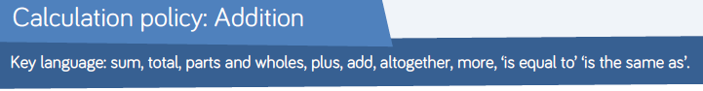

|  |  |  |  |
| --- | --- | --- | --- |
| Strategies | Concrete | Pictorial | Abstract |
| **Key Stage 1** | | | |
| Combining two parts to make a whole: part- whole model | Use cubes to add two numbers together as a group or in a bar.  8  1 | Image result for part whole model  C:\Users\b.smith\AppData\Local\Microsoft\Windows\Temporary Internet Files\Content.IE5\2GUHBRQ0\Simple-Flower-Outline-12183-large[1].png  Image result for part whole model additionC:\Users\b.smith\AppData\Local\Microsoft\Windows\Temporary Internet Files\Content.IE5\2GUHBRQ0\Simple-Flower-Outline-12183-large[1].pngC:\Users\b.smith\AppData\Local\Microsoft\Windows\Temporary Internet Files\Content.IE5\2GUHBRQ0\Simple-Flower-Outline-12183-large[1].png  Use pictures to add two numbers together as a group or in a bar.  C:\Users\b.smith\AppData\Local\Microsoft\Windows\Temporary Internet Files\Content.IE5\2GUHBRQ0\Simple-Flower-Outline-12183-large[1].png  C:\Users\b.smith\AppData\Local\Microsoft\Windows\Temporary Internet Files\Content.IE5\2GUHBRQ0\Simple-Flower-Outline-12183-large[1].png | 4 + 3 = 7  10= 6 + 4  5  3  Use the part-part whole diagram as shown above to move into the abstract. |
| Starting at the bigger number and counting on | Start with the larger number on the bead string and then count on to the smaller number 1 by 1 to find the answer. | 12 + 5 = 17    Start at the larger number on the number line and count on in ones or in one jump to find the answer. | 5 + 12 = 17  Place the larger number in your head and count on the smaller number to find your answer. |
| Regrouping to make 10. | 6 + 5 = 11  Start with the bigger number and use the smaller number to make 10. | Use pictures or a number line. Regroup or partition the smaller number to make 10. | 7 + 4= 11  If I am at seven, how many more do I need to make 10. How many more do I add on now? |
| Adding three single digits | 4 + 7 + 6= 17  Put 4 and 6 together to make 10. Add on 7.    Following on from making 10, make 10 with 2 of the digits (if possible) then add on the third digit.  Add together three groups of objects. Draw a picture to recombine the groups to make 10. | C:\Users\b.smith\AppData\Local\Microsoft\Windows\Temporary Internet Files\Content.IE5\OZODVY09\pitr-Candy-icon[1].pngC:\Users\b.smith\AppData\Local\Microsoft\Windows\Temporary Internet Files\Content.IE5\OZODVY09\pitr-Candy-icon[1].pngC:\Users\b.smith\AppData\Local\Microsoft\Windows\Temporary Internet Files\Content.IE5\OZODVY09\pitr-Candy-icon[1].pngC:\Users\b.smith\AppData\Local\Microsoft\Windows\Temporary Internet Files\Content.IE5\OZODVY09\pitr-Candy-icon[1].pngC:\Users\b.smith\AppData\Local\Microsoft\Windows\Temporary Internet Files\Content.IE5\OZODVY09\pitr-Candy-icon[1].pngC:\Users\b.smith\AppData\Local\Microsoft\Windows\Temporary Internet Files\Content.IE5\OZODVY09\pitr-Candy-icon[1].pngC:\Users\b.smith\AppData\Local\Microsoft\Windows\Temporary Internet Files\Content.IE5\OZODVY09\pitr-Candy-icon[1].pngC:\Users\b.smith\AppData\Local\Microsoft\Windows\Temporary Internet Files\Content.IE5\OZODVY09\pitr-Candy-icon[1].pngC:\Users\b.smith\AppData\Local\Microsoft\Windows\Temporary Internet Files\Content.IE5\OZODVY09\pitr-Candy-icon[1].pngC:\Users\b.smith\AppData\Local\Microsoft\Windows\Temporary Internet Files\Content.IE5\OZODVY09\pitr-Candy-icon[1].pngC:\Users\b.smith\AppData\Local\Microsoft\Windows\Temporary Internet Files\Content.IE5\OZODVY09\pitr-Candy-icon[1].pngC:\Users\b.smith\AppData\Local\Microsoft\Windows\Temporary Internet Files\Content.IE5\OZODVY09\pitr-Candy-icon[1].pngC:\Users\b.smith\AppData\Local\Microsoft\Windows\Temporary Internet Files\Content.IE5\OZODVY09\pitr-Candy-icon[1].pngC:\Users\b.smith\AppData\Local\Microsoft\Windows\Temporary Internet Files\Content.IE5\OZODVY09\pitr-Candy-icon[1].pngC:\Users\b.smith\AppData\Local\Microsoft\Windows\Temporary Internet Files\Content.IE5\OZODVY09\pitr-Candy-icon[1].pngC:\Users\b.smith\AppData\Local\Microsoft\Windows\Temporary Internet Files\Content.IE5\OZODVY09\pitr-Candy-icon[1].pngC:\Users\b.smith\AppData\Local\Microsoft\Windows\Temporary Internet Files\Content.IE5\OZODVY09\pitr-Candy-icon[1].pngC:\Users\b.smith\AppData\Local\Microsoft\Windows\Temporary Internet Files\Content.IE5\OZODVY09\pitr-Candy-icon[1].pngC:\Users\b.smith\AppData\Local\Microsoft\Windows\Temporary Internet Files\Content.IE5\OZODVY09\pitr-Candy-icon[1].pngC:\Users\b.smith\AppData\Local\Microsoft\Windows\Temporary Internet Files\Content.IE5\OZODVY09\pitr-Candy-icon[1].pngC:\Users\b.smith\AppData\Local\Microsoft\Windows\Temporary Internet Files\Content.IE5\OZODVY09\pitr-Candy-icon[1].pngC:\Users\b.smith\AppData\Local\Microsoft\Windows\Temporary Internet Files\Content.IE5\OZODVY09\pitr-Candy-icon[1].pngC:\Users\b.smith\AppData\Local\Microsoft\Windows\Temporary Internet Files\Content.IE5\OZODVY09\pitr-Candy-icon[1].pngC:\Users\b.smith\AppData\Local\Microsoft\Windows\Temporary Internet Files\Content.IE5\OZODVY09\pitr-Candy-icon[1].pngC:\Users\b.smith\AppData\Local\Microsoft\Windows\Temporary Internet Files\Content.IE5\OZODVY09\pitr-Candy-icon[1].pngC:\Users\b.smith\AppData\Local\Microsoft\Windows\Temporary Internet Files\Content.IE5\OZODVY09\pitr-Candy-icon[1].pngC:\Users\b.smith\AppData\Local\Microsoft\Windows\Temporary Internet Files\Content.IE5\OZODVY09\pitr-Candy-icon[1].pngC:\Users\b.smith\AppData\Local\Microsoft\Windows\Temporary Internet Files\Content.IE5\OZODVY09\pitr-Candy-icon[1].pngC:\Users\b.smith\AppData\Local\Microsoft\Windows\Temporary Internet Files\Content.IE5\OZODVY09\pitr-Candy-icon[1].pngC:\Users\b.smith\AppData\Local\Microsoft\Windows\Temporary Internet Files\Content.IE5\OZODVY09\pitr-Candy-icon[1].png  +  +  + | Combine the two numbers that make 10 and then add on the remainder. |
| Partitioning to add |  |  |  |
| **Key Stage 2** | | | |
| Column method- no regrouping | 24 + 15=  Add together the ones first then add the tens. Use the Base 10 blocks first before moving onto place value counters. | After practically using the base 10 blocks and place value counters, children can draw the counters to help them to solve additions.  T O |  |
| Column method- regrouping | Make both numbers on a place value grid.    Add up the units and exchange 10 ones for one 10.    Add up the rest of the columns, exchanging the 10 counters from one column for the next place value column until every column has been added.  This can also be done with Base 10 to help children clearly see that 10 ones equal 1 ten and 10 tens equal 100.  As children move on to decimals, money and decimal place value counters can be used to support learning. | Children can draw a pictoral representation of the columns and place value counters to further support their learning and understanding. | Start by partitioning the numbers before moving on to clearly show the exchange below the addition.      As the children move on, introduce decimals with the same number of decimal places and different. Money can be used here. |

**Subtraction**



|  |  |  |  |
| --- | --- | --- | --- |
| Strategies | Concrete | Pictorial | Abstract |
| **Key Stage 1** | | | |
| Taking away ones | Use physical objects, counters, cubes etc to show how objects can be taken away.  6 – 2 = 4 | Cross out drawn objects to show what has been taken away. | 18 -3= 15  8 – 2 = 6 |
| Counting back | Make the larger number in your subtraction. Move the beads along your bead string as you count backwards in ones.  13 – 4  Use counters and move them away from the group as you take them away counting backwards as you go.  http://3.bp.blogspot.com/-mFqQPE4k1TE/VGzRNnUu30I/AAAAAAAAAJM/12p6qvgkmoE/s1600/EvenOdd_ColoredCounters_Scattered.jpg | Count back on a number line or number track    Start at the bigger number and count back the smaller number showing the jumps on the number line.    This can progress all the way to counting back using two 2 digit numbers. | Put 13 in your head, count back 4. What number are you at? Use your fingers to help. |
| Part, part whole model | Link to addition- use the part whole model to help explain the inverse between addition and subtraction.  If 10 is the whole and 6 is one of the parts. What is the other part?  10 - 6 = | Use a pictorial representation of objects to show the part part whole model. | 10  5  Move to using numbers within the part whole model. |
| Make 10 | 14 – 9 =  Make 14 on the ten frame. Take away the four first to make 10 and then takeaway one more so you have taken away 5. You are left with the answer of 9. | Start at 13. Take away 3 to reach 10. Then take away the remaining 4 so you have taken away 7 altogether. You have reached your answer. | 16 – 8=  How many do we take off to reach the next 10?  How many do we have left to take off? |
| Find the difference | Compare amounts and objects to find the difference.    Image result for two towers of cubes  Use cubes to build towers or make bars to find the difference  Use basic bar models with items to find the difference | Count on to find the difference.  http://image.slidesharecdn.com/intro-to-sm-1220840292402057-8/95/intro-to-singapore-math-13-728.jpg?cb=1345557040  Draw bars to find  the difference between 2 numbers. | Hannah has 23 sandwiches, Helen has 15 sandwiches. Find the difference between the number of sandwiches. |
| Partitioning to subtract |  |  |  |
| **Key Stage 2** | | | |
| Column method without regrouping | Use Base 10 to make the bigger number then take the smaller number away.  Show how you partition numbers to subtract. Again make the larger number first. | Draw the Base 10 or place value counters alongside the written calculation to help to show working. | http://media.showmeapp.com/files/205114/pictures/thumbs/1100814/last_thumb1379615590.jpg  [https://encrypted-tbn3.gstatic.com/images?q=tbn:ANd9GcS1ohiHkzn0cS0nvwRP-5EyK0TDGl_A1tbsAl0XjNPBssTas4YVeQ](http://www.google.co.uk/url?sa=i&rct=j&q=&esrc=s&source=images&cd=&cad=rja&uact=8&ved=0CAcQjRxqFQoTCPyKt_H6h8kCFUNEFAodiFAGCA&url=http://huppiemama.com/teaching-subtraction-using-manipulatives/&bvm=bv.106923889,d.d2s&psig=AFQjCNEr_xOQu7fhwvMOMFTIen6kpdc03g&ust=1447317198959935)This will lead to a clear written column subtraction. |
| Column method with regrouping | Use Base 10 to start with before moving on to place value counters. Start with one exchange before moving onto subtractions with 2 exchanges.  Make the larger number with the place value counters  Start with the ones, can I take away 8 from 4 easily? I need to exchange one of my tens for ten ones.    Now I can subtract my ones.  Now look at the tens, can I take away 8 tens easily? I need to exchange one hundred for ten tens.    Now I can take away eight tens and complete my subtraction    Show children how the concrete method links to the written method alongside your working. Cross out the numbers when exchanging and show where we write our new amount. | Draw the counters onto a place value grid and show what you have taken away by crossing the counters out as well as clearly showing the exchanges you make.  When confident, children can find their own way to record the exchange/regrouping.  Just writing the numbers as shown here shows that the child understands the method and knows when to exchange/regroup. | Children can start their formal written method by partitioning the number into clear place value columns.  Moving forward the children use a more compact method.  This will lead to an understanding of subtracting any number including decimals. |

**Multiplication**



|  |  |  |  |
| --- | --- | --- | --- |
| Strategies | Concrete | Pictorial | Abstract |
| **Key Stage 1** | | | |
| Doubling | Use practical activities to show how to double a number. | Draw pictures to show how to double a number. | Partition a number and then double each part before recombining it back together. |
| Counting in multiples | Count in multiples supported by concrete objects in equal groups. | Use a number line or pictures to continue support in counting in multiples. | Count in multiples of a number aloud.  Write sequences with multiples of numbers.  2, 4, 6, 8, 10  5, 10, 15, 20, 25 , 30 |
| Repeated addition | Use different objects to add equal groups. |  | Write addition sentences to describe objects and pictures. |
| Arrays- showing commutative multiplication | http://www.australiancurriculumlessons.com.au/wp-content/uploads/2013/05/arrays-multiplication-division-lesson.jpgCreate arrays using counters/ cubes to show multiplication sentences. | Draw arrays in different rotations to find **commutative** multiplication sentences.  http://mathcentral.uregina.ca/QQ/database/QQ.02.06/maro1.1.gif  Link arrays to area of rectangles. | Use an array to write multiplication sentences and reinforce repeated addition. |
| **Key Stage 2** | | | |
| Grid Method | Show the link with arrays to first introduce the grid method.    4 rows of 10  4 rows of 3  Move on to using Base 10 to move towards a more compact method.  4 rows of 13  Move on to place value counters to show how we are finding groups of a number.We are multiplying by 4 so we need 4 rows.    Fill each row with 126.    Add up each column, starting with the ones making any exchanges needed.      Then you have your answer. | Children can represent the work they have done with place value counters in a way that they understand.  http://www.highviewschool.org.uk/wp-content/uploads/2014/05/IMG_0499-300x225.jpgThey can draw the counters, using colours to show different amounts or just use circles in the different columns to show their thinking as shown below. | Start with multiplying by one digit numbers and showing the clear addition alongside the grid.  http://www.mumsnet.com/system/1/assets/files/000/006/988/6988/35010b289/original/328x164xgrid-method-explained-2.jpg.pagespeed.ic.zL-KyDdiL2.jpg  Moving forward, multiply by a 2 digit number showing the different rows within the grid method. |
| Column multiplication | https://primarysite-prod.s3.amazonaws.com/0c4eb252d34643748228179a3d582154_1x1.jpegChildren can continue to be supported by place value counters at the stage of multiplication.  It is important at this stage that they always multiply the ones first and note down their answer followed by the tens which they note below. | Bar modelling and number lines can support learners when solving problems with multiplication alongside the formal written methods.  C:\Users\nathan.crook\AppData\Local\Microsoft\Windows\Temporary Internet Files\Content.Outlook\3IR2FLXR\photo (7).JPG  *C:\Users\nathan.crook\AppData\Local\Microsoft\Windows\Temporary Internet Files\Content.Outlook\3IR2FLXR\photo (5).JPG* | Start with long multiplication, reminding the children about lining up their numbers clearly in columns.  If it helps, children can write out what they are solving next to their answer.  http://ictedusrv.cumbria.ac.uk/maths/SecMaths/U1/images/pic018.gif    This moves to the more compact method.  http://amsi.org.au/teacher_modules/B1/B1t102.png |

**Division**



|  |  |  |  |
| --- | --- | --- | --- |
| Strategies | Concrete | Pictorial | Abstract |
| **Key Stage 1** | | | |
| Sharing objects into groups | I have 10 cubes, can you share them equally in 2 groups? | Children use pictures or shapes to share quantities.  C:\Users\b.smith\AppData\Local\Microsoft\Windows\Temporary Internet Files\Content.IE5\C9ORAZE7\Simple-Flower-Outline-12183-large[1].pngC:\Users\b.smith\AppData\Local\Microsoft\Windows\Temporary Internet Files\Content.IE5\C9ORAZE7\Simple-Flower-Outline-12183-large[1].pngC:\Users\b.smith\AppData\Local\Microsoft\Windows\Temporary Internet Files\Content.IE5\C9ORAZE7\Simple-Flower-Outline-12183-large[1].pngC:\Users\b.smith\AppData\Local\Microsoft\Windows\Temporary Internet Files\Content.IE5\C9ORAZE7\Simple-Flower-Outline-12183-large[1].pngC:\Users\b.smith\AppData\Local\Microsoft\Windows\Temporary Internet Files\Content.IE5\C9ORAZE7\Simple-Flower-Outline-12183-large[1].pngC:\Users\b.smith\AppData\Local\Microsoft\Windows\Temporary Internet Files\Content.IE5\C9ORAZE7\Simple-Flower-Outline-12183-large[1].pngC:\Users\b.smith\AppData\Local\Microsoft\Windows\Temporary Internet Files\Content.IE5\C9ORAZE7\Simple-Flower-Outline-12183-large[1].pngC:\Users\b.smith\AppData\Local\Microsoft\Windows\Temporary Internet Files\Content.IE5\C9ORAZE7\Simple-Flower-Outline-12183-large[1].png  8 ÷ 2 = 4 | Share 9 buns between three people.  9 ÷ 3 = 3 |
| Division as grouping | Divide quantities into equal groups.  Use cubes, counters, objects or place value counters to aid understanding. | Use a number line to show jumps in groups. The number of jumps equals the number of groups.    http://gcamath3.weebly.com/uploads/9/1/4/0/9140392/200455_orig.jpgThink of the bar as a whole. Split it into the number of groups you are dividing by and work out how many would be within each group. | 28 ÷ 7 = 4  Divide 28 into 7 groups. How many are in each group? |
| Division within arrays | Link division to multiplication by creating an array and thinking about the number sentences that can be created.  Eg 15 ÷ 3 = 5 5 x 3 = 15  15 ÷ 5 = 3 3 x 5 = 15 | Draw an array and use lines to split the array into groups to make multiplication and division sentences. | Find the inverse of multiplication and division sentences by creating four linking number sentences.  7 x 4 = 28  4 x 7 = 28  28 ÷ 7 = 4  28 ÷ 4 = 7 |
| **Key Stage 2** | | | |
| Division with a remainder | 14 ÷ 3 =  Divide objects between groups and see how much is left over  Image result for counters | Jump forward in equal jumps on a number line then see how many more you need to jump to find a remainder.  Draw dots and group them to divide an amount and clearly show a remainder. | Complete written divisions and show the remainder using r.  http://amsi.org.au/teacher_modules/G7/G7_qt2%202.png |
| Short division | Use place value counters to divide using the bus stop method alongside  42 ÷ 3=  Start with the biggest place value, we are sharing 40 into three groups. We can put 1 ten in each group and we have 1 ten left over.    We exchange this ten for ten ones and then share the ones equally among the groups.  We look how much in 1 group so the answer is 14. | http://www.studyzone.org/testprep/math4/d/division2.gifStudents can continue to use drawn diagrams with dots or circles to help them divide numbers into equal groups.  Encourage them to move towards counting in multiples to divide more efficiently. | Begin with divisions that divide equally with no remainder.  Move onto divisions with a remainder.  Finally move into decimal places to divide the total accurately. |