
BISCOVEY ACADEMY
NEWSLETTER
29TH FEBRUARY 2016

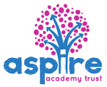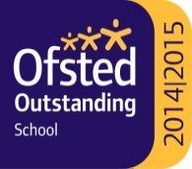


ACHIEVEMENT AWARDS

Year 3
Class 1 –Riley Moon
Class 2— Ethan Jones
Overall Jem Ward

Year 4
Class 1A – Daniel Kirk
Class 5— Bailey Watts
Class 6— Ki Wilton
Overall Ella White

Year 5
Class 7 – Joshua Simmons
Class 8 – Daisy Staynings
Class 12 – Emily Andrews

Overall Ellie Rogers

Year 6
Class 4 – Bradley George
Class 9 – Jack Neesom
Class 10 – Poppy Speake

Overall – Finley Turner

‘CONGRATULATIONS TO YOU ALL’

Dear Parents….

WORLD BOOK DAY REMINDER
FANCY DRESS!
This Thursday 3rd March we will be inviting the children to dress as their favourite book character to celebrate ‘World Book Day’.
ALSO Book Exchange
On the same day we will hold a book exchange/sale. Children’s books (in good condition) can be brought in from 29th February to Class 8 and will then be on sale for a small sum of 10p – 50p. Thank you.

NEEDED FOR SCIENCE WEEK!
Small junk modeling items (cereal boxes, food packets) for Mr Jewell. Thank you.

SWIMMING SESSION UPDATE
Friday swimming sessions have now finished and will resume again in September. A gala for selected children only, however, will take place this Friday.

REMINDER
The School Photographer
will be here from 8.30am next Monday 7th March for INDIVIDUAL/FAMILY photos!
No appointment necessary

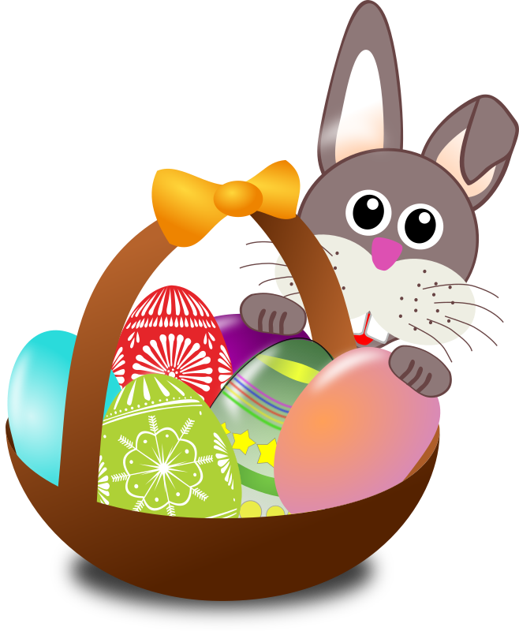
ADVANCE NOTICE
Decorated Egg Competition
We will be holding a
Decorated Egg (Hard Boiled)
competition on THURSDAY 24TH MARCH
There will be prizes for 1st, 2nd and 3rd in each year group and a Cadburys Creme Egg for each entry.

DIARY DATES

School Photographer - Monday 7th March - starting at 8.30am
for individual/family photos

PARENT’S MEETINGS – 14TH TO 18TH MARCH
THEREFORE AFTER SCHOOL CLUBS WILL BE CANCELLED THIS WEEK!

Last day of term -Thursday 24th March at 1.45pm

Summer term – Monday 11th April to
Thursday 21st July
(Half term – 30th May to 3rd June)

STAFF TRAINING DATE – Friday 22nd July 2016 (SCHOOL CLOSED)

LOST ITEMS OF UNIFORM!!
Charlotte Tucker – Hooded PE Top (NAMED)
Jack Ratcliffe – Black, school shoes, size 2 (Clarkes)
A pupil in Class 2 – A pink swimming mask after
swimming on Friday 29th January

PLEASE CHECK P.E. BAGS FOR THE ABOVE ITEMS
THANK YOU

Needed for our CHRISTMAS FAYRE (ON 3RD DECEMBER) – please
Books and Toys
Cakes (Plates to follow)
McDonalds Cups (to follow – please fill if you can)
Wine (adult tombola)
Chocolate (chocolate tombola)
Tins/Packets suitable for tombola

