Biscovey Academy
Homework – Year 5 Anglo Saxons

It is expected that children aim to choose one of the following activities to complete each week to support their current learning in the classroom. In addition to these activities, you should aim to read regularly and access either Sumdog or Times Table Rock Stars.

Find out about Canute (Cnut) the Great. Produce a fact file on him and include a picture.  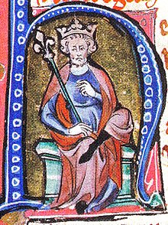 | Anglo Saxon honey and oat cakes  Ingredients:  250g porridge oats, 125g unsalted butter, 50g chopped dried apple or apricots, 4 tablespoons runny honey, 1 teaspoon of ground cinnamon.  Preheat the oven to 180C  Melt the butter. Mix in the dry ingredients and then stir in the honey.  Spoon 12 dollops onto a greased baking tray.  Bake for about 10-12 minutes.  Remember to take a photo. | 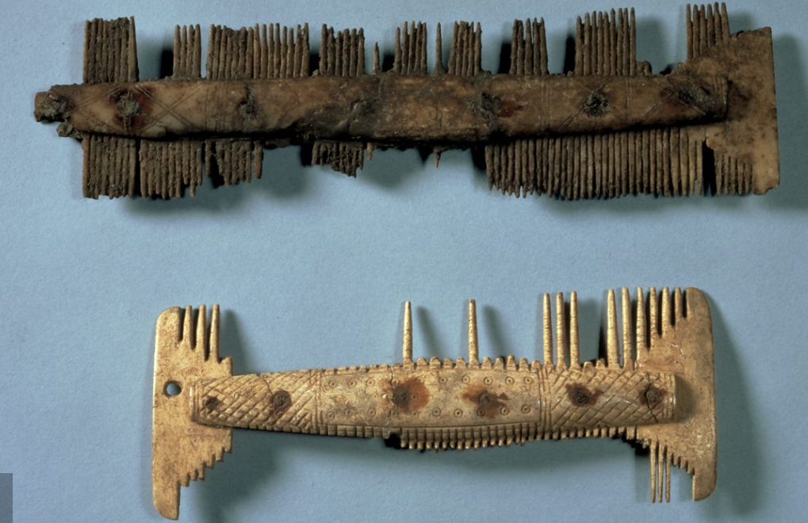  - What do you think these Anglo-Saxon artefacts are? What were they used for?  - What are they made of?  - What do they tell you about Anglo-Saxon life?
Beowulf’s boasts  The epic poem, Beowulf, is over 3000 lines long! The poem has lots of examples of ‘boasts’ which were commonly used bt Anglo Saxon warriors. They would gather in the mead hall and make these boasts before going into battle. The Anglo -Saxons saw them as a symbol of the warrior’s bravery; the bigger the better!  eg Only I could defeat this monster!  My heart is firm, my hands are calm!  Draw a picture of you as an Anglo-Saxon warrior and write your boasts around it. | Illuminated lettering  Images of people, animals, plants or mythological creatures were sometimes added to enhance a letter. Because many people couldn’t read at the time, they were a way of communicating a story or message without using words.  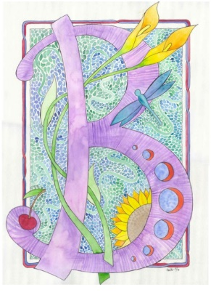  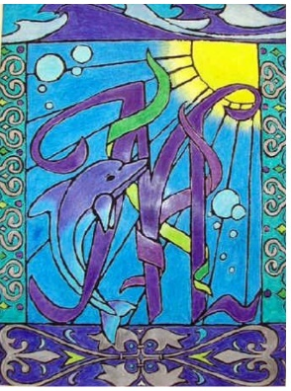  Transform the first letter of your name into an illuminated letter. | Anglo-Saxon Maths 1  See below.  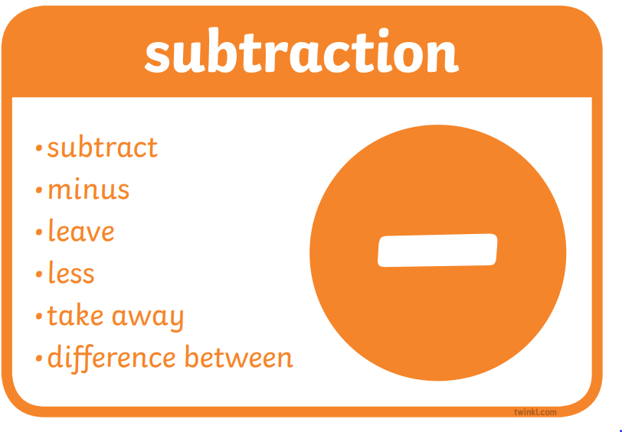
Anglo-Saxon Maths 2  See below | Anglo-Saxon place names  Many places in England have Anglo-Saxon place names. Use the information in the table belowto translate these modern-day place names to their original Anglo-Saxon meaning.  Aldborough, Askham, Barwick, Bewerley, Carlton, Fleetham, Morley, Stonyhurst, Tonbridge, Wainfleet, Walden, Walshford,  Can you find other places which have Anglo-Saxon names? | Anglo-Saxon Maths 3  See below
