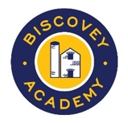
Biscovey Academy
Homework – Year 5 VICTORIANS

It is expected that children aim to choose one of the following activities to complete each week to support their current learning in the classroom. In addition to these activities, you should aim to read regularly and access either Sumdog or Times Table Rock Stars.

LOWRY  Laurence Stephen Lowry was a famous English painter. He was born on 1 November 1887. He developed a distinctive style of painting and is best known for his urban landscapes peopled with human figures, often referred to as "matchstick men".  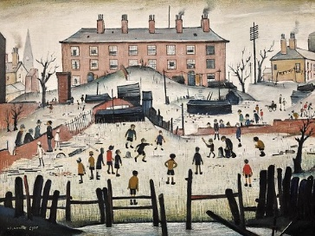  - Either copy a Lowry painting or have a go at creating your own painting/picture in his style. Perhaps base it on your own home and family. | VICTORIAN TOYS  Victorian toys were usually made from wood, metal and paper. Children from rich families played with toys such as clockwork trainsets, toy soldiers, Jack-in-the-box, rocking horses and dolls. Children from poorer families played with homemade toys such as peg dolls and wooden boats.  - Make your own version of a Jack-in-the-box using paper and card or a peg doll.  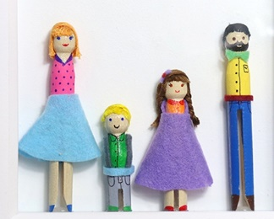  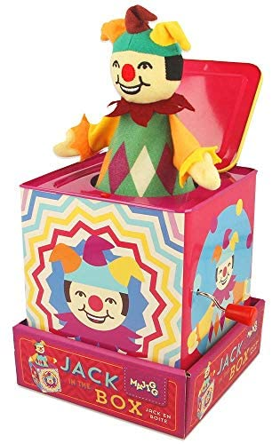 | VICTORIAN INVENTORS  The Victorian age was a time of great innovation and change and produced many innovators, inventors and scientists such as Alexander Graham Bell, Isambard Kingdom Brunel and Sarah Guppy.  - Produce a fact file on someone of your choice. Don’t forget to include a portrait/picture.  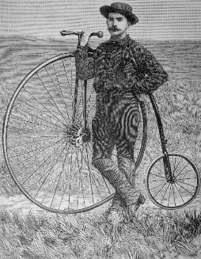  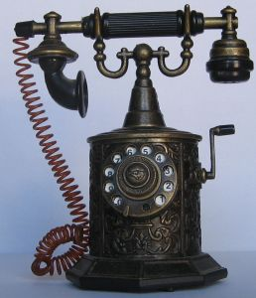
MAP WORK  Draw or trace a world map and mark on the countries that were part of the British Empire. | LETTER WRITING  Write a letter to Charles Darwin to explain why it is important that your favourite animal doesn’t become extinct. | MATHS – BAR CHART  Research Kings and Queens of the past. Create a bar chart to compare the length of Queen Victoria’s reign with other Kings and Queens.
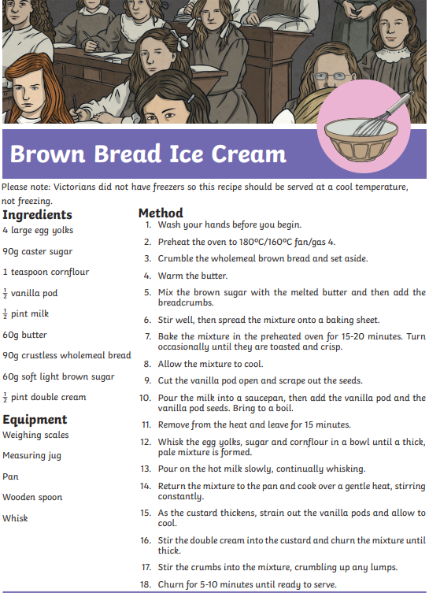  MATHS - MEASURING  Don’t forget to take a photo! | CHARLES DICKENS  Charles Dickens is one of the most famous writers of the 19th century, and his books are still loved by people all over the world. Some of his most famous works include A Christmas Carol, Great Expectations, and Oliver Twist.  - Take one of his book titles and design your own front cover. Also find out what the book is about and write a short blurb.  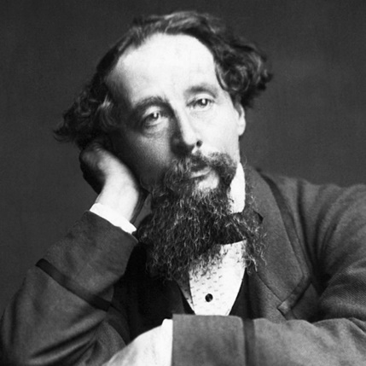 | MATHS - MEASURING  Measure out ingredients to make a Victoria sponge cake.  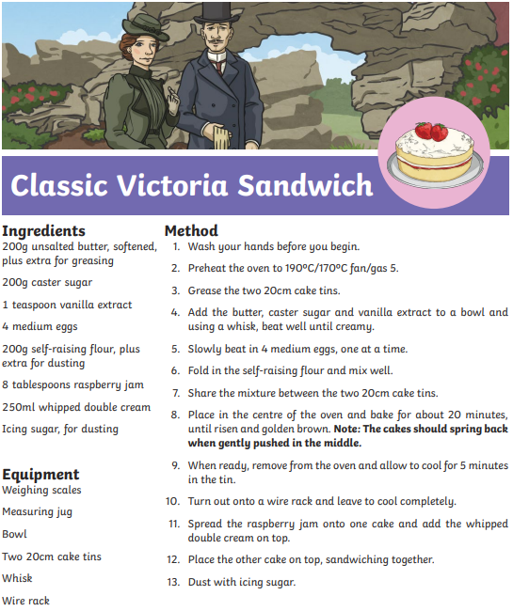  Don’t forget to take a photo!

